Fowler United Methodist Church
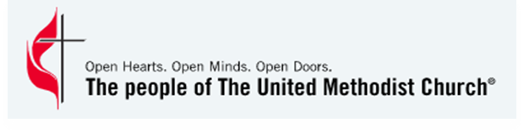
3928 N. Howard St.
Spokane WA. 99205
Feel free to call if you have any questions! 325-3242

Child’s Full Name: ____________________________________________
Birthday ____________________________________________
Grade ____________________________________________
Your Childs Areas of Interest: □ Board Games □ Cooking
□ Music □ Crafts
□ Guitar □ Dance
□ Chess □ Help with Homework
Street Address: ____________________________________________
Food Allergies: ____________________________________________
How can we help your child? ____________________________________________
Parent’s Full Name: ____________________________________________
Phone Number: ____________________________________________
Email Address: ____________________________________________
Alternate Contact – Name: ____________________________________________
Phone: ____________________________________________
□ My child has my permission to walk to the Church and will be picked up by 4:45 pm
□ I will bring my child to the Church and pick them up by 4:45 pm.

The following people ARE authorized to bring / pick up my child (ID will be required to pick up all children)
Name _______________________________________ Phone _________________________________
Name _______________________________________ Phone _________________________________
The following people are NOT authorized to pick up my child per the attached document.

Name ________________ ________________ Relationship to Child_____________________________
Number of People in your household _______
(On occasion we will be sending food home for the family)
Note that all children must be picked up no later than 4:45 PM

Parent Signature of Approval for child to participate in the program.
Note: All Fowler Participants will have completed a background check

